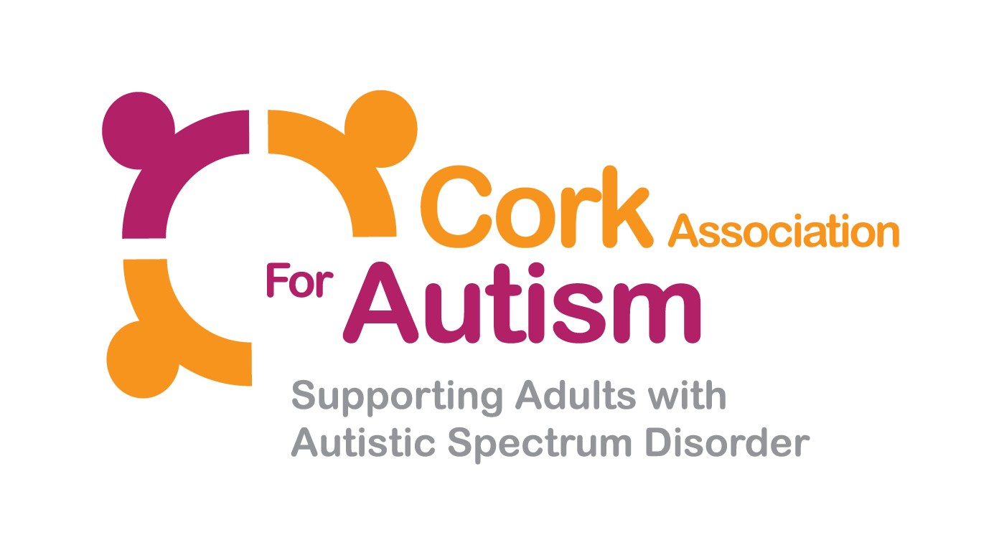
Cork Association for Autism are delighted to be recruiting for Care Support Workers for Day Services, Residential Services, Respite and Home Support Services.
Applications are invited for the following posts:

Care Support Worker
Ref: CAA / CSW / 0218
To create a panel
Full Time: 39 hours per week

Relief Care Support Worker
Ref: CAA / RCSW / 0218
Relief Contract

Closing Date for receipt of application forms is 1pm, 9th March 2018

Full details of the position are contained in the application pack. Cork Association for Autism reserve the right to shortlist based on both essential and desirable criteria. If you do not receive a response within 3 weeks of the closing date, your application has been unsuccessful and you will not receive further correspondence.

Please note if successful at interview, the applicant will have to complete Garda Síochána Vetting.

For the Full Time Care Support Worker post a panel of successful candidates will be formed. Candidates who obtain a place on the panel and who fulfil the conditions of the selection process may, within the life of the panel, be considered for subsequent approved vacancies.

To obtain an application pack, visit our website: www.corkautism.ie

Please send application pack to recruitment@corkautism.ie or send a large SAE quoting the appropriate reference to:
Sarah Jane Lee (Recruitment)
Cork Association for Autism
Unit 4, Barryscourt Industrial Estate,
Carrigtwohill, Co.Cork

Cork Association for Autism is an equal opportunities employer

Roles and Responsibilities (Operational)

Care Support Workers
- To provide the highest standard of care and support in accordance with the ethos of the organisation, national policy, HIQA Standards and legislation.
- To support Service Users to reach their potential, by providing care & support based on their assess need.
- To build a positive relationship with all stakeholders, with the central focus being a person centred, safe and effective service.
- To report to Team Leader/Social Care Leader on a daily basis.
- To respond effectively and effectively in accordance to the organisational policies and procedures and HSE/HIQA Guidance in regards to medication management, risk management, positive behaviour support, health and safety, fire safety, complaints, safeguarding, restrictive practices, incidents and accidents.
- To take responsibility for ensuring your own professional development, this will include ensuring that the Team Leader or Social Care Leader carries out supervision with you on a monthly basis.

Personal Specification – Care Support Worker

A. SHORTLISTING CRITERIA
 | Essential Criteria
Circumstances | 1. To be over 23 years old – this an occupational requirement  2. To be flexible as the role involves 24 hour cover on a rota / shift basis.  3. To possess a full current driving licence that allows you to drive a manual vehicle in ROI.  Consideration will be given to alternative travelling proposals in respect of applicants with a disability who cannot hold a driver’s licence.
Qualifications for Full Time Position:  Qualifications for Relief Position: | 1. A minimum of FETAC Level 5 Award in this field or equivalent related qualification for Full time positions  1. Working towards a Fetac Level 5 Award in this field or equivalent related qualification for Relief positions.
Experience | 1. A minimum of 6 months experience of supporting people in a caring field as a paid employee, volunteer, work experience or carer.
Shortlisting will be based on the evidence that you supply on your application form to satisfactorily demonstrate how, and to what extent, you meet the above criteria. The Shortlisting Panel will not make assumptions as to your circumstances, qualifications or experience.

B. COMPETENCIES
Candidates who are shortlisted for interview will be required to demonstrate how, and to what extent, they meet some or all of the competencies listed below during the interview.
- Customer & Client Focus
To provide a high quality service by motivating, mentoring and supporting Service Users to achieve social inclusion and their individual recovery through an empathetic, professional and holistic approach.
- Communicating Effectively
Excellent interpersonal, listening, communication (internal and external) and record keeping skills.
- Team & Partnership Working
To engage with, build and maintain effective and professional relationships with Service Users, colleagues, external agencies and third parties.
- Personal Development, Performance & Professionalism
To take responsibility for your continuous personal development and actively participate in training and development initiatives to achieve your agreed objectives.

- Continuous Improvement & Results Delivery
Demonstrate use of initiative, innovation and contribution to continuous improvement of service provision.
- Supplementary Information

- This is a regulated post and will be subject to a satisfactory Garda Síochána Vetting

