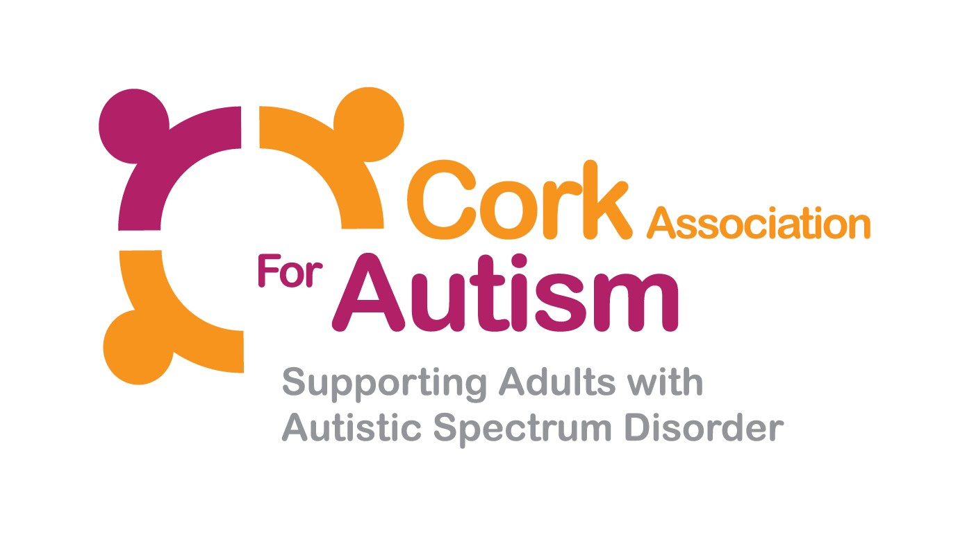

Cork Association for Autism

Application Pack: Care Support Worker

June 2018

Contents of Pack:

- Care Support Worker Job Description/Terms & Conditions
- Care Support Worker Person Specification
- Application Procedure
- Application Form

CARE SUPPORT WORKER – CORK ASSOCIATION FOR AUTISM

JOB DESCRIPTION

The Cork Association for Autism has grown significantly since its foundation in 1978. It has evolved into a centre of excellence for adults with Autism and Asperger Syndrome and has improved the quality of lives of many adults with autism and their families. Over 300 individuals benefit from the services available which include Residential Care, Day Service, Respite, Home Support and an Asperger Syndrome Support Service (Aspect).

Purpose of the job

The primary role of the Care Support Worker is to provide the highest standard of care and support in accordance with the ethos of the organization, national policy, HIQA standards and legislation.

Reporting to:

Care Support Workers report to a Team Leader on a day-to-day basis and directly to the Manager as required.

Main Areas of Duty

- Support Service Users reach their potential, by providing care and support based on their assessed needs

- Build a positive relationship with all stakeholders, with the central focus being a person centred, safe and effective service.

- Respond effectively in accordance to the organizational policies and procedures and HSE/HIQA Guidance in regards to medication management, risk management, positive behavior support, health and safety, fire safety, complaints, safeguarding, restrictive practices, incidents and accidents.

- Take responsibility for ensuring your own professional development, this will include ensuring that the Team Leader or Social Care Leader carries out supervision with you on a regular basis.

- Participate in Mandatory Training

- Perform such duties (including key-working and administrative duties) as may be assigned from time to time by CAA management.

Terms and Conditions

Salary: The salary is €25,529 - €37,680 Department of Health (HSE) 2017 Consolidated Payscale, Care Assistant (Intellectual Disability Services) (pro rata if part-time position). It is anticipated that new entrants to the Cork Association for Autism will be appointed on the 1st point of the scale. Incremental credit, should it be awarded, will be based on previous relevant experience. This is an incremental salary scale for Full time permanent staff.
Relief Staff: The salary per hour is €12.54 Department of Health (HSE) 2017 Consolidated Payscale as a Care Assistant (Intellectual Disability Services), Year 1.

Annual Leave: 20 days – 160 hours (pro rata if relief or part-time position). Recognises 9 Public Holidays

Full terms and conditions are contained in the Employee Contract, and in a Staff Handbook, which is issued with and forms part of the Employee Contract at CAA.
CARE SUPPORT WORKER - C
PERSON SPECIFICATION

 | Essential | Desirable
Education &  Training | Educated to a QQI Level 5 standard or equivalent qualification in the Care Field | A third-level qualification  Education/training in an area related to ASD
Circumstances | To be over 23 years old – this is an occupational requirement  And  To possess a full current driving licence that allows you to drive a manual vehicle in ROI. Consideration will be given to alternative travelling proposals in respect of applicants with a disability who cannot hold a driver’s licence.
Experience/  Knowledge | (See ‘Education and Training’ above)  A minimum of six months experience of supporting people in a caring field as a paid employee, volunteer, work experience or carer.  Working knowledge and understanding of HIQA and HSE guidelines  Knowledge of the role, including the nature and range of services provided | Experience in a care setting or comparable service
Demonstrable  Aptitudes | Active, empathetic and impartial listening skills  Ability to absorb, analyse and evaluate information from a variety of sources  Capacity to deliver information impartially, accurately and clearly  IT skills (particularly re usage of email, word and excel)  Capacity to work on own initiative and also to take direction from supervisors/line managers in a team environment  Oral and written communication skills  Analytical and critical thinking capacities  Organisational & administrative skills
Demonstrable Commitments | Active commitment to continuous self-evaluation and service-evaluation, meeting targets and improvement  Active contribution to a supportive, respectful, creative and dignified team working environment  Maintenance of the highest standards of honesty and integrity
Other Requirements | All employees of CAA must be self-motivated, punctual and reliable  Flexibility is required as the role involves 24 hour cover on a rota / shift basis.  Attendance at meetings and training courses outside business hours is occasionally required.

APPLICATION PROCEDURE

Submission of Application

Applicants for this position must submit a typed application form (one copy) by 1pm 11th July 2018

To avoid unnecessary duplication in your answers, please read the entire application form carefully before attempting to complete it.

The completed application form should be emailed (as an attachment) to recruitment@corkautism.ie (with ‘Care Support Worker’ in the subject line).
Alternatively please post application form to Sarah Jane Lee, Unit 4, Barryscourt Industrial Estate, Carrigtwohill, Co.Cork

The application form must be submitted in either Microsoft Word or pdf. No other format will be accepted. Documents stored on online storage sites – e.g. OneDrive, Cloud, Dropbox, Google Drive etc. – will not be accepted. Please ensure that your Word of pdf application form is submitted as an attachment, not as a link to an online storage site.

Please do not submit any other documentation with the application form. Any such documents submitted will not be taken into consideration.

Receipt of your emailed application form will be acknowledged by email.

Canvassing will disqualify.

Failure to submit an application form on or before the closing date and time will disqualify. Candidates should note that there can be a time delay in receiving email applications. We recommend that candidates allow a minimum of one hour for their application to reach recruitment@corkautism.ie

Closing date/time: 1pm 11th July 2018

Shortlisting and Interview

Shortlisting will apply. The decision regarding which candidates to shortlist will be made solely on the basis of the information contained in the application form. Scoring of applications is based on the criteria outlined in the Person Specification.

If shortlisted, candidates will be informed by email as to date, times and location of interview. If you do not receive a response within 3 weeks, your application has been unsuccessful, and you will not receive further correspondence.

Shortlisted candidates will be given the opportunity at interview to indicate which panel/s (i.e. full-time and/or part-time, permanent and/or temporary) they wish to be placed on.

CLOSING DATE FOR RECEIPT OF APPLICATION BY EMAIL:

1pm, 11th July 2018

